PE03 – Output Screenshots
Browser
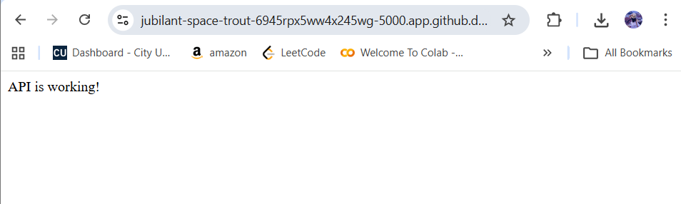

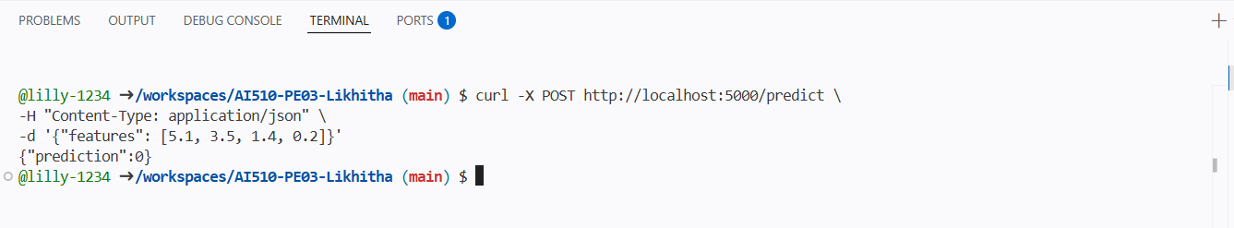
Output
